**Initio Programming: Sensors**



**AIM:** After completing this worksheet you should be able to describe the sensors on the Initio robot and use Python to get information from them.

**You Need:** To complete this worksheet you need to have an Initio that is connected to a keyboard, mouse and monitor (see WS1) and to understand how to start IDLE from the Linux Command Line (see WS2) and how to control the pan/tilt servos (see WS3).

The Initio robot has two different kinds of sensors:

1. **Ultrasonic:** It has an ultrasonic sensor which uses sound and echoes to measure distances.
2. **Infrared:** It has several infrared sensors that measure how much infrared light is reflected. These can be used both to measure distances (like with the ultrasonic sensor) and to measure colour – for instance a black surface reflects less infra-red light than a white surface.

You can use Python to get values from the sensors.

**The Ultrasonic Sensor**

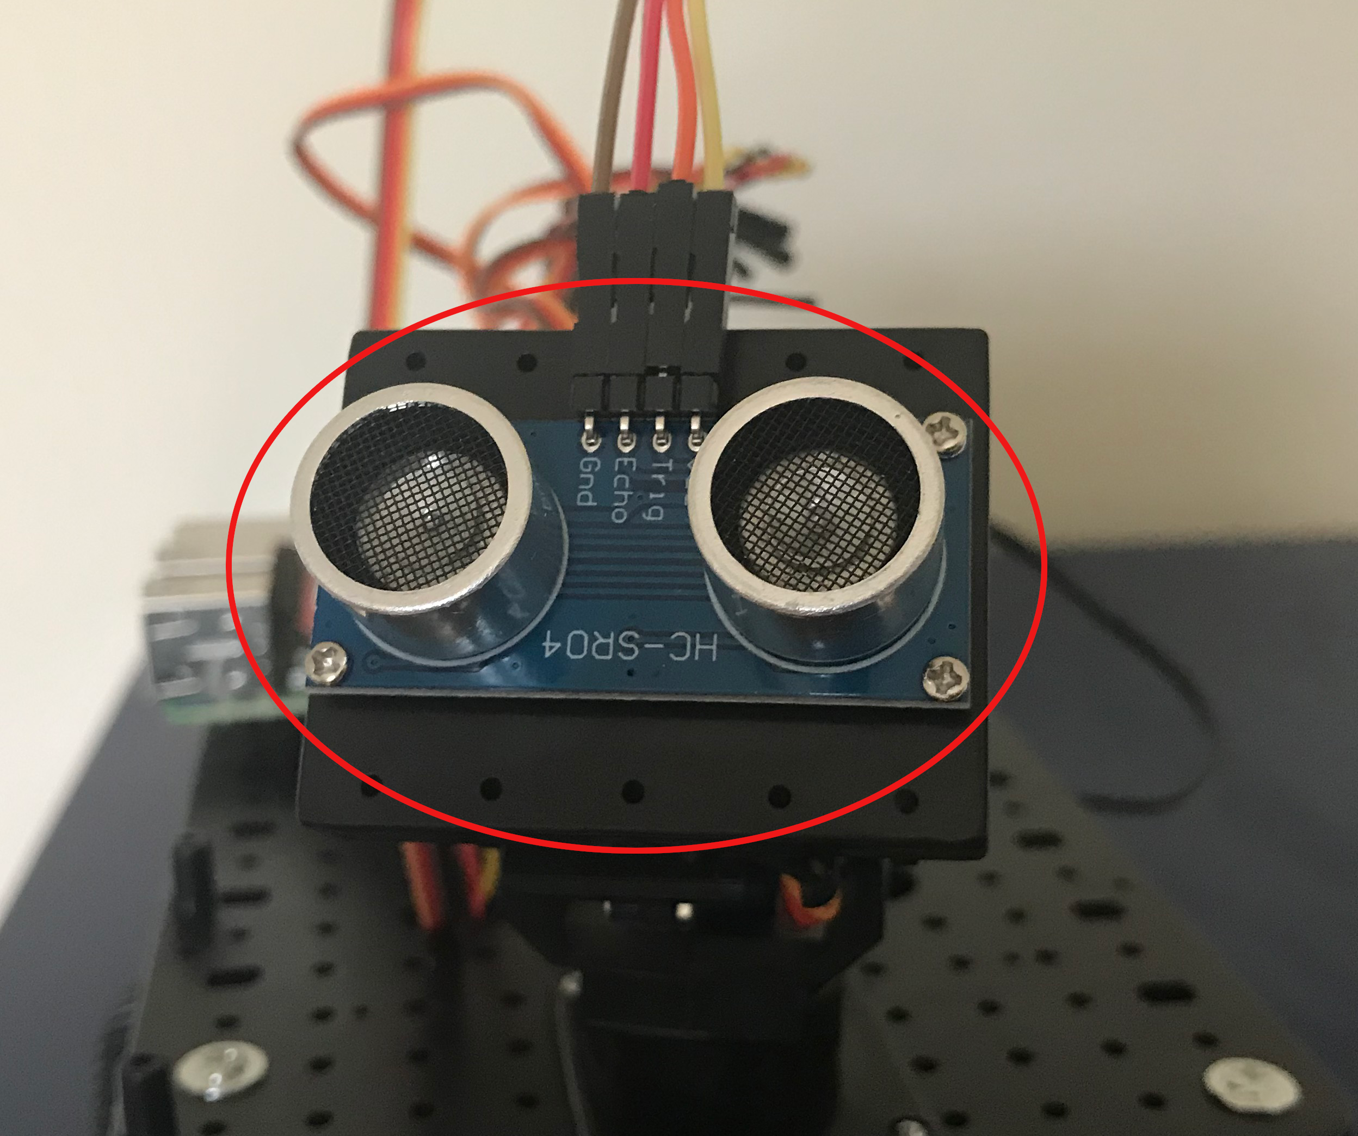

The Ultrasonic Sensor

Locate the ultrasonic sensor on your Initio robot.

There is one command you can use to get information from the ultrasonic sensor. This is:

>>> initio.getDistance()

initio.getDistance(); returns the distance in cm to the nearest reflecting object. A value of zero means it does not detect an object

Type initio.getDistance()



What value do you get?



Try pointing the sensor at the ceiling or a far wall and getting the distance.

What value do you get?

Now try putting an object close to the sensor.



What value do you get?



The ultrasonic sensor is the sensor you can move using the initio.setServo command discussed in WS3.

Place an object in front of the robot but a little to one side of the ultrasonic sensor. Use initio.setServo to move the sensor and see what difference it makes to the result from initio.getDistance()

What command(s) did you type to move the sensor in order to detect the object?



**Infrared Sensors**

The Initio’s infrared sensors are organised into two groups: sensors for detecting obstacles and sensors for detecting lines.

There are two sensors for detecting obstacles:

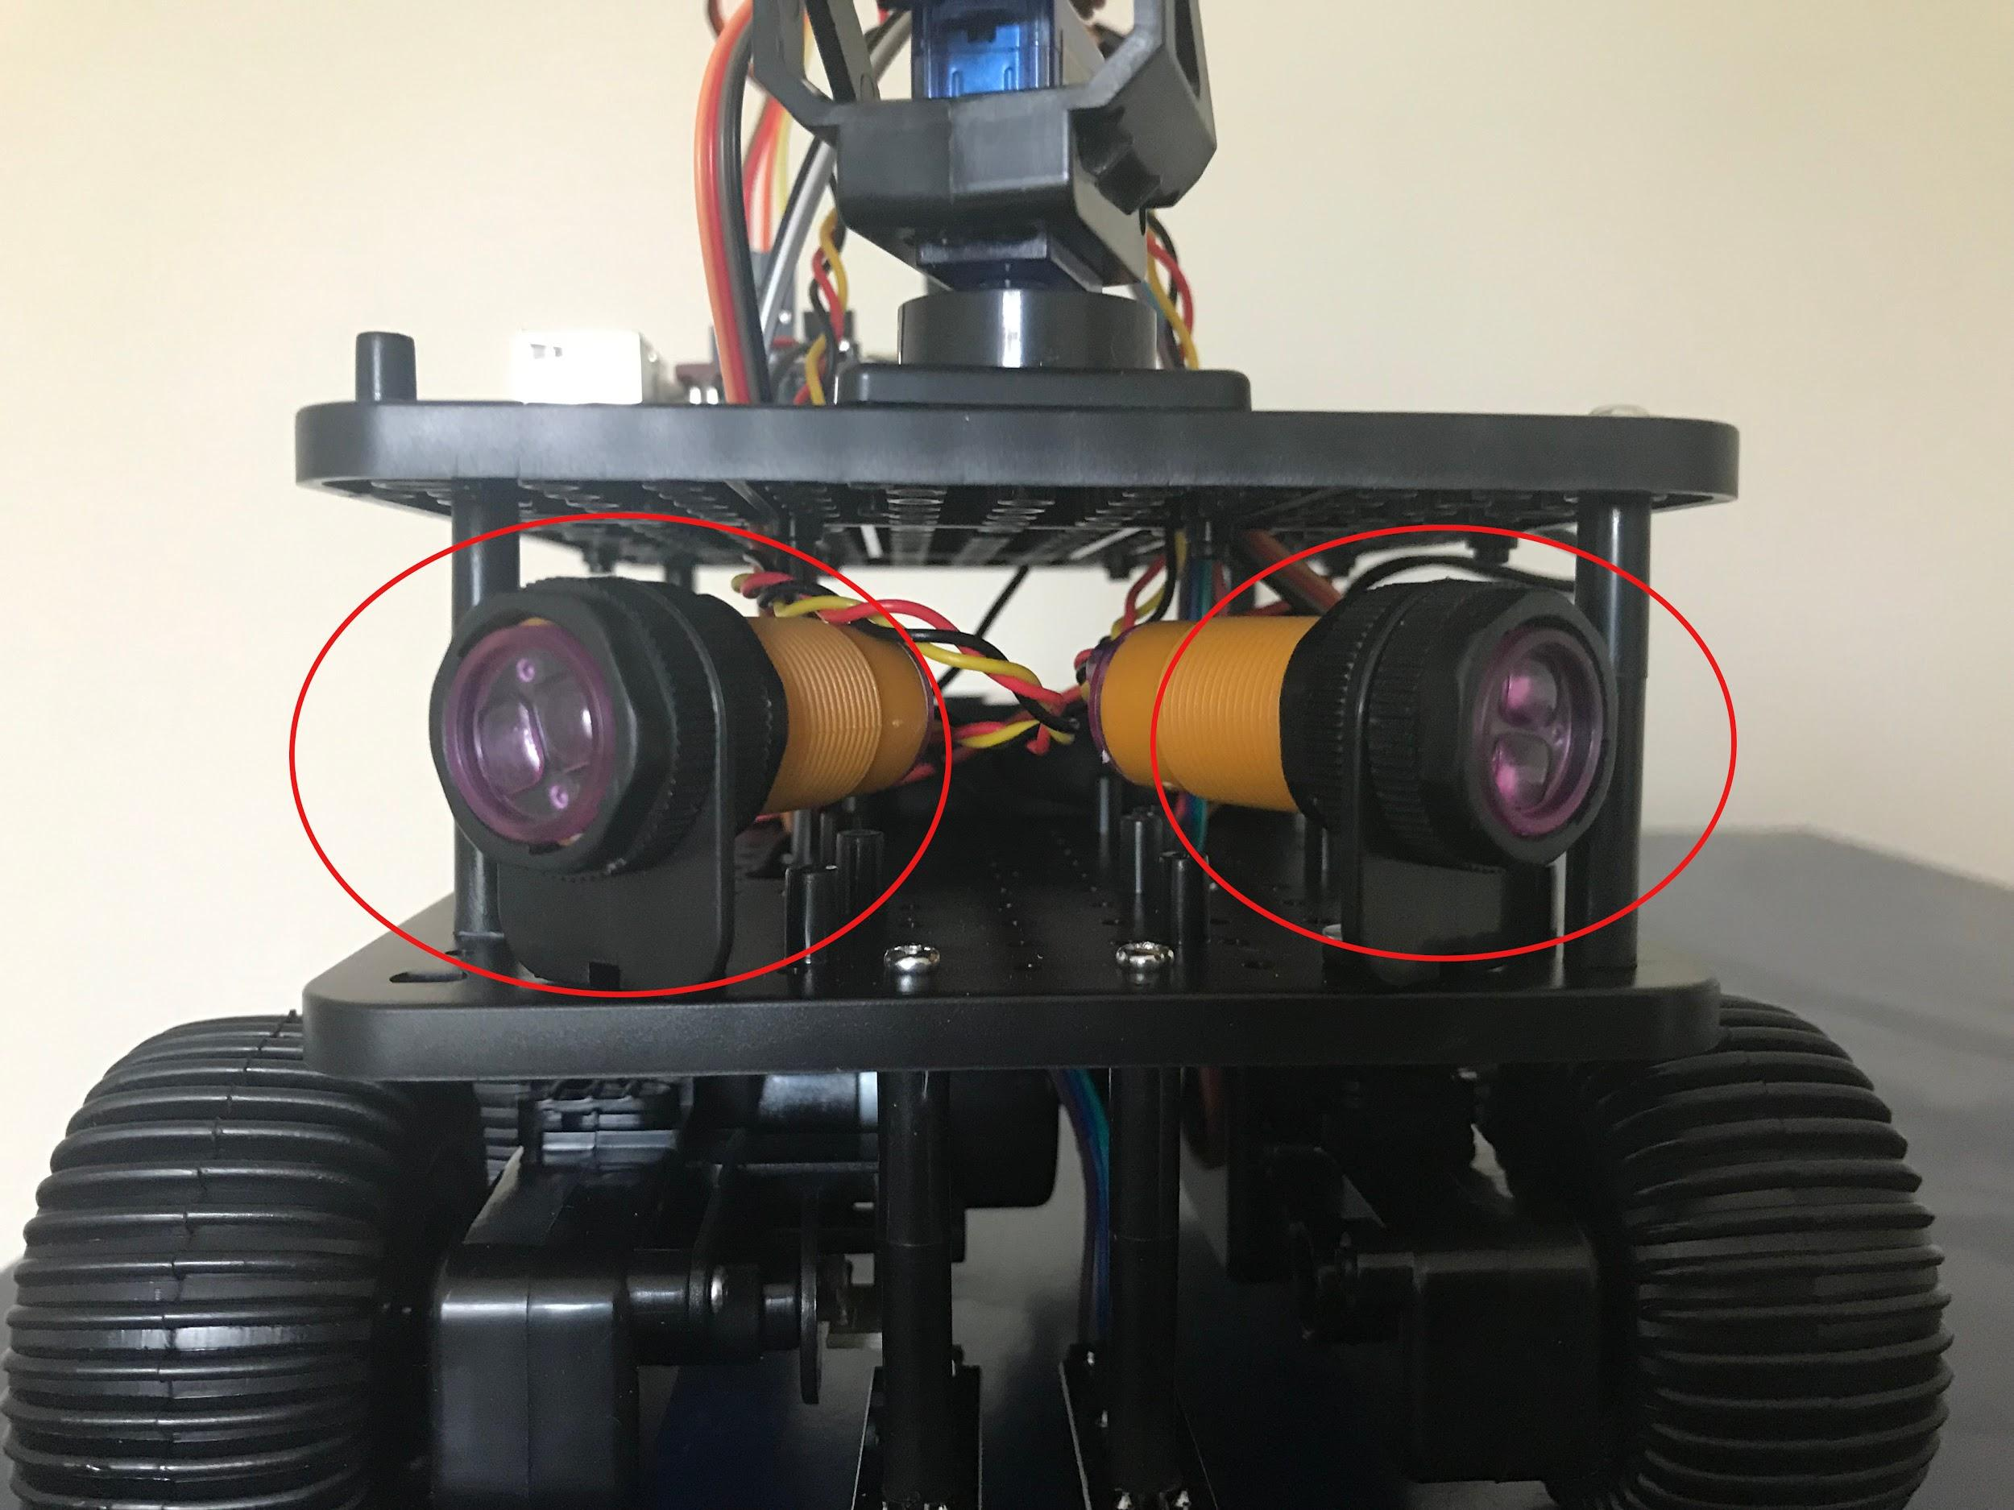

The Obstacle Sensors

There are three commands for getting information from the obstacle sensors:

>>> initio.irLeft()

returns **True** if the Left IR Obstacle sensor detects an obstacle and **False** otherwise

>>> initio.irRight()

returns **True** if the Right IR Obstacle sensor detects an obstacle and **False** otherwise

>>> initio.irAll()

returns **True** if either of the Obstacle sensors detect an obstacle and **False** otherwise

Use a ruler and the obstacle sensor commands to work out how far away something needs to be to count as an obstacle.

Answer:

Is this answer the same both obstacle sensors? YES/NO

The Initio’s other infrared sensors are used to detect how dark the colour of the surface the robot stands on is. These are referred to as “line sensors” since their primary use is for detecting black lines on white surfaces.

There are two line sensors and you will need to turn your Initio over in order to see them.

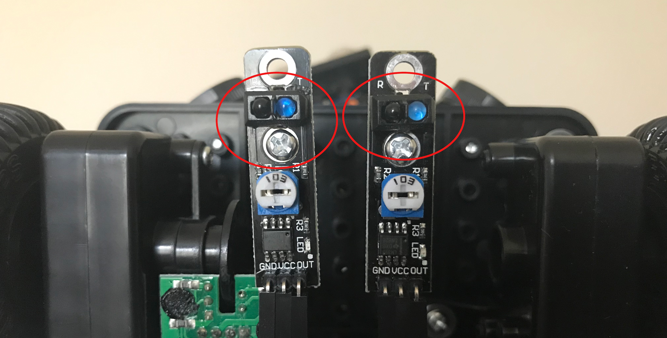

The Line Sensors

There are two command for getting information from the line sensors:

>>> initio.irLeftLine()

returns state of Left IR Line sensor

>>> initio.irRightLine()

returns state of Right IR Line sensor

Get a piece of white paper with a black line drawn on it. What do the python commands return if the Pi2Go is over the black line?

What do they return if the Pi2Go is over the white parts of the paper



**Remember:** When you have finished working with the robot, type initio.cleanup()at the command line, quit IDLE, then select Shutdown from the Raspberry Pi menu item. Once the robot has shut down, switch it off.



University of Liverpool, 2019

This work is licensed under a [Creative Commons Attribution-NonCommercial-ShareAlike 4.0 International License](https://creativecommons.org/licenses/by-nc-sa/4.0/).